# Section A

1. Paradigm Pet Professionals want to provide quality information on pet care, something that sounds reasonable for a company calling themselves professionals. However, their scope is much larger than what the current website infers. The site has some good information on the necessities of cats and dogs. For example, the cat page provides details on feline care throughout their live in a broad sense. The dog page has information on the general lifestyle of dogs. However, the content only partially meets Paradigm’s expectations. They want to include the more general lifestyle of cats, and the timeline of dog milestones. Any other pet has barely-any information, and most likely none at all.

The audience is expecting a wider scope of information as well. There are a significant number of people that have non-cat and non-dog pets. Without a page specific to those pets, most people will probably leave as soon as they see that their pet isn’t listed, although the FAQ page does have *some*additional information.

1. The functionality of the site is atrocious and fails the audience’s needs. The links seem to work, but that’s about it. The navigation only partially works depending on the subpage, and the search bar does nothing. The navigation bar sometimes highlights a part, sometimes doesn’t. It’s unlikely that anyone would bother trying to navigate the site after 10 seconds. It doesn’t matter how good the content of the site is if its functionality is this bad. The stakeholders need a site that draws people in and works correctly. The poor functionality reflects just as poorly on Paradigm. After all, if they can’t get a simple website to work correctly, how is anyone supposed to trust that they do their work correctly?
2. The navigation bar, as mentioned above, doesn’t work between pages consistently. This makes it difficult for the audience to find the information they are looking for. For instance, the “Home” button doesn’t work when you are on the FAQ Page. The menu changes order on the FAQ page as well. Generally, an FAQ page would be about the business process, not more care information that doesn’t have a home. At the very least, the FAQ page should have sections separating the types of pets or separate the pets from more general business questions. As for the stakeholders, the website doesn’t have any way for customers to contact them. It’s difficult to run a business when you have clear communication with your customers, so trying to run one without communicating directly with your customers is doomed to fail. Users can clearly see that Paradigm has information on cats and dogs, but with the content in the FAQ, users wouldn’t know Paradigm helps with other types of pets.

# Section B

1. The stake holders need the website to host more content, be consistent in its functionality, and show contact information. The audience needs to intuitively know where to go on the site, find the information they need easily, and know that PPP is looking out for them
2. Adding a new bird page will reach a greater scope of individuals, bird owners. It will provide useful information beyond the FAQ, and will help the owner know exactly where to go
3. The colors will be changed to better accommodate the needs of everyone. Currently they don’t look very nice. The information for the dogs and cats will be mostly the same. The FAQ page will likely be dropped unless more generic questions are found. The home page will be more about the company and help guide the audience to the right page
4. This structure will provide more information to the audience initially, so they know exactly where they want to go. As a result, the stakeholders will get more clientele and be able to provide more helpful information that they didn’t have before.
5. The new site won’t have very many secondary elements at the moment, if at all. There will be some references to the About Us and Contact Us tabs throughout the site, but every element is primary. Naturally, the site will change over time, and secondary elements will be added as more specific content is added for each type of pet.
   1. For now, I believe that my structure is the most efficient use of each page. It doesn’t make sense to have several subpages and secondary navigation elements for the specified content. However, when the content becomes more specific, such as breaking up each category into breeds (i.e. a Dogs main menu with individual breeds as sub menus), sub menus would be appropriate. Adding more navigational structures would require significantly more clicks to get the same information, making it difficult for the users to find what they need. Since PPP has not included such a breakdown of information, it doesn’t make sense to overcomplicate the UI for future functionality, especially when adding more functionality wouldn’t be particularly more difficult than adding the content already would be. It’s important for the stakeholders to present their content in a clean and efficient manner. It allows easier improvement of the site and addition of content. It also leaves the audience satisfied with the product, encouraging more communication and interaction.

# Section C

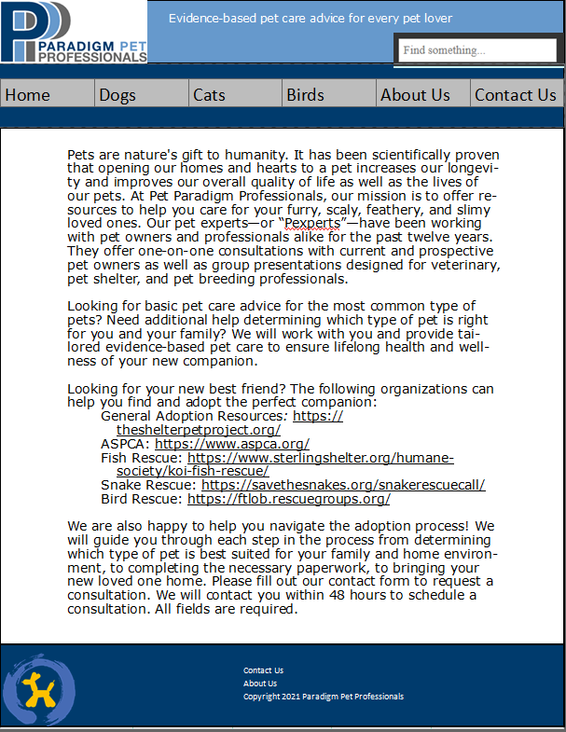

# Section D

1. Accessibility
   1. Task: Ensure the site is accessible to everyone, especially those with special needs
   2. Domain: Functionality/User Feedback
   3. Target: HTML Code
   4. Owner: Web Developer
   5. Time: Prior to code going into production; as new technology standards and tools become available
   6. Assets: Web Server, Code, New Technology
   7. Stakeholder needs: This will ensure that all customers can use the site. The customers with special needs will often have pets in a supporting role, so this site will be very useful to them
2. Search Engine Optimization and Content
   1. Task: Optimize searches and also ensure that the content of the site will match the search terms
   2. Domain: Performance
   3. Target: HTML, CSS, JS code
   4. Owner: Web developer and Content provider
   5. Time: As content is changed; as new tools that assist optimization become available
   6. Assets: Development system, Content information
   7. Stakeholder needs: This will help the stake holder by increasing their web traffic and therefore getting more clients
3. Maintenance
   1. Task: Regularly check website for any functionality issues, ensure website is secure, and keep the webserver up to date
   2. Domain: Performance/Functionality
   3. Target: Webserver, JS code
   4. Owner: Web developer and webserver host
   5. Time: Monthly
   6. Assets: Development system, Webserver
   7. Stakeholder needs: This will help ensure that the site is secure, accurate, and working, all of which support the company’s credibility
4. Responsive Design
   1. Task: Ensure that the website is useable on both a computer and Mobile device
   2. Domain: Functionality/performance
   3. Target: HTML, CSS, JS code
   4. Owner: Web developer
   5. Time: As content is changed, browsers are updated, and new device technology is released
   6. Assets: Development system
   7. Stakeholder needs: Many people use their phone for all internet browsing. It is important to ensure they will have a good experience, which in turn increases business
5. Search Engine Optimization for Mobile Devices
   1. Task: Optimize the search engine for mobile devices
   2. Domain: Performance/Functionality
   3. Target: HTML, CSS, JS code
   4. Owner: web developer and content provider
   5. Time: As content is changed; as new tools that assist optimization become available
   6. Assets: Development system, Content information
   7. Stakeholder needs: as previously stated, this will increase traffic to the site and therefore procure more clientele